**High Quality Mobile Crowd-Sensing Based on Urban Public Transport Vehicles**

**Chaowei Wang, Chensheng Li, Cai Qian, Weidong Wang, Xiuhua Li**

**ABSTRACT**

Mobile crowd sensing is a prospective paradigm for smartphones, which collects ubiquitous data easily in large-scale city. Nowadays, public transport vehicles are mostly widely used and affordable in many countries. A bus embedded with substantial sensors also can be adopted as participator in crowd sensing. However, distinct from smartphones, the trajectory of bus is scheduled and its location is predicted, these character shed opportunities to achieve high quality crowd sensing, which highly depends on the spatial-temporal coverage of sensing data. Therefore, based on the predictable trajectory of vehicles, we design a novel model and present an approximation algorithm to select vehicles to participate in urban sensing for maximizing spatiotemporal coverage with constrained sensing reward. We theoretically prove that the selection of vehicles problem is NP-hard, the proposed algorithm can achieve a performance guarantee no less than $(1-1/e)$ of theoretical optimum. The performance of our algorithm is simulated with real T-Drive trajectory dataset. The results show that our algorithm achieves a good coverage closer to optimum and outperform some exiting alternative algorithms.

**Keywords—**Mobile crowd sensing, spatial temporal coverage, approximation algorithm, performance guarantee

**INTRODUTION**

With the rapid advance of sensing, communication, and mobile computing, mobile crowd-sensing [1] has become a paradigm attracting much attention for collecting distribute sensory data and distributing to the general public. With the help of mobile crowd-sensing the cost of data collection and dissemination tasks over wide range of region can be significantly reduced. Being carried by users locating in different place, smartphones can easily collect ubiquitous data and share data with potential users in neighborhood [2], [3]. The vehicle-based mobile crowd-sensing with similar mobility, distributed in large is evolving rapidly. Equipped with various onboard sensors such as GPS, video cameras, gas sensor and also communication module, a vehicle becomes a powerful crowd-sensing application like as a smartphone to collect data and carry on a various of sensing task, including traffic monitoring [4][5], environment monitoring [6] and urban Wi-Fi characterization [7], etc.

A vehicle-based mobile crowd-sensing system is typically composed of two parts: cloud management platform (CMP) and mobile vehicles embedded with crowd sensing application. An example of vehicle-based crowd sensing is shown in Fig.1. The cloud management platform is responsible for selecting a set of vehicles to participate in urban crowd sensing task and processing perceived data which forwarded from vehicles to provide data services to user. Once a vehicle receives authorization of the CMP, it collects the required data and then upload them to CMP. This indicates that a vehicle-based mobile crowd sensing system with widespread geographical distribution of vehicles is capable of supporting large-scale range monitoring [8].

Generally, it is greatly important to select vehicles to participate in collaborative sensing, which manifest the success of vehicle-based mobile crowd sensing. Assuming an extreme case that the CMP select all vehicles to execute crowd sensing task, apparently, it can perceive the surroundings and achieve what it is assigned to do, but multiple vehicles in the same region at the same time introduces data redundancy due to a single vehicle is sufficient to cover a geographical region. Therefore, the vehicle usually receive credit or non-monetary reward from CMP [9]-[11] with constraint budget, and selects a set of vehicle from all vehicles under operation that meet the user’s requirements for better crowd sensing performance[11].



Fig.1. An example of vehicle-based crowd sensing application. Buses embedded with plentiful sensors are distributed over a large city. Cloud management platform assign sensing task to the recruited vehicle which can contribute to the sensing tasks by returning their sensed data to CMP. And then CMP processes the received data to provide to user.

The location of vehicles have great influence on the quality of vehicle-based mobile crowd sensing [12], because of the CMP assigns tasks to vehicles that operates in different regions. There is another extreme case in which no vehicle is operating in the region of interest at a specific time that result in blank data. Obviously, the quality of crowd sensing is sensitive to location and time, so the spatial-temporal coverage is a fundamental metric of the vehicle-based mobile crowd sensing quality. Particularly, spatial-temporal coverage intends to cover as many areas of interest as possible or make sure all areas are covered at least once for a period of time. In reality, we are supposed to be aware that the spatial-temporal coverage of sensing data of vehicle-based mobile crowd sensing is more dynamic on account of each vehicle keeps moving persistently throughout the city as his own schedule.

However, public transport buses, which is distinct from taxi or private car without operating plans, strictly follow an explicit timetable made by its operator. Hence the location of each bus is predictable in spite of the highly dynamic mobility, which shed a chance to achieve high quality crowd sensing. Because each bus is able to cover many areas for a period of time. Besides, taking into consideration of the future location of vehicles can effectively prevent the quality of crowd-sensing from affecting for high mobility instead of only depend on current location as smartphone-based crowd-sensing does[13].

In this paper, we concentrate on how to achieve a high quality of crowd sensing with full use of the predictable location of buses. After analysis on the relations between spatial-temporal coverage and the location of vehicle, we formulate the problem of selection vehicle (SV) for maximizing the spatial-temporal coverage of city with constraint budget. Through thoroughly proof, we find that SV is NP-hard. And we design a truthful and efficient approximation algorithm, called ECQA, to select a set of vehicle from all candidates under operation with a high efficiency (minimal budget and maximizing spatial-temporal coverage), which can approximate the optimal solution within a guarantee performance no less than $(1-e^{-1})$, with polynomial-time computation complexity. We also theoretically prove the ECQA guarantee is truthfulness.

**SYSTEM MODEL AND PROBLEM FORMULATION**

**A. System Model**

We consider a vehicle-based crowd sensing system consisting of a CMP and many vehicles embedded with substantial sensors. The CMP periodically assigns sensing tasks to be completed by running vehicle.

In an urban area, we divide road into a serial of small segments. As an example shows in figure 2, let $R$ denote the set of all small segments, $R=\{r_{1}, r_{2}, r_{3}, …,r_{k}\}$. When the CMP broadcasts a crowd-sensing task to be finished for a period of time, i.e. We assume the time T is discrete and we get $T=\{t_{1}, t_{2}, t_{3}, …,t_{m}\}$.The distribution of vehicle is of large-scale, each vehicle equipped with the sensor module that we has designed in [14] is able to take crowd-sensing tasks. Assume there are *n* vehicles can take sensing assignments and the set of vehicles is denoted by $V=\{v_{1}, v_{2}, v_{3}, …, v_{n}\}$. Initially, the CMP predicts the current position of all vehicles according to the timetable and broadcast the data packet until receive the ACK, if the prediction is not consistent with the actual current location obtained by Global Positioning System (GPS) [15] employed in vehicle, it will be updated, respectively. With the initial location of vehicles and scheduled timetable, we can get the location of a vehicle $v_{i}$ at a specific time $t_{j}$, which is denoted by $l_{i}(t_{j})∈R$. Thus the trajectory of n vehicles can be represented as follows:

$L\left(V\right)=\left[\begin{matrix}l_{1}\left(t_{1}\right) & ⋯ & l_{1}\left(t_{m}\right) \\ ⋮ & ⋱ & ⋮ \\ l_{n}\left(t_{1}\right) & ⋯ & l_{n}\left(t_{m}\right)\end{matrix}\right]$ (1)

where the size of $L(V)$ is $n×m$.

In practice, as we are not anticipating that all vehicles are involved in crowd sensing due to data redundancy. For example, in terms of traffic monitoring, nearby vehicles usually upload the similar traffic information which should be avoided. Therefore, we regulate that a vehicle who is selected to take part in crowd sensing will gain a reward paid by CMP and the budget of CMP is limited to no morn than $C_{max}.$ Then, we define the sensing reward.

**Definition 1: Sensing Reward (SR)** a vehicle is selected to complete tasks often associated with a reward paid by CMP. Let $c_{i}$ denote the reward to $v_{i}$, the reward can be acquired through online bidding [1]. Then, the reward vector $C$ for all vehicles is:

$C=\{c_{1}, c_{2},c_{3},…,c_{n}\}$ (2)

With the constraint of budget of CMP, not all vehicles participate in crowd-sensing, we adopt an indication vector $ϕ$ to imply whether a vehicle $v_{i}$ is selected or not,

$ϕ_{i}=\left\{\begin{aligned}1 v_{i }ϵ Ω \\ 0 otherwise \end{aligned}\right.$ (3)

where $Ω⊆V$ is the set of chosen vehicles. Let $C$ be the total reward to buses in $Ω$, which can be computed as,

$C(Ω)=[C,ϕ]$ (4)

As mentioned above, the quality of crowd sensing is related with spatial-temporal coverage, which means to cover as many regions of interest as possible and ensure each road segment to be covered once at least within a sensing time T. We also introduce the notion of spatial-temporal coverage.

**Definition 2: Spatial-temporal Coverage (STC)** determines the quality of crowd-sensing. Formally, which can be defined as:

$STC\left(Ω\right)=\sum_{t_{j}∈T}{⋃_{v_{i}∈Ω }l_{i}(t_{j})}$ (5)

Then we show an example to explain the implication of STC. In Fig.2, the scheduled trajectory of Bus 1, Bus 2, Bus 3, Bus 4 is {BC, AB, AD, DE }, {BC BE, EH}, {EH, HD, AD, AB, BE},{EF, BE,AB, AD, DH}, respectively. In a period time $t_{1}, t_{2}, t_{3}, t_{4}$, the location of Bus 1 to Bus 4 is { BC, AD, DE, BC}, {BC, BE, BC,BE },{EH, HD, AB, BE}, {AB, BE, AD ,DH}, respectively. From equality (1), we get that,

$L\left(V\right)=$ (6)

If the CMP with limited budget is capable of selecting two vehicles to participate crowd-sensing, then we consider two cases as bellows,

$STC\left(\{Bus 1, Bus 2\}\right)=$ (7)

$STC(\left\{Bus 3, Bus 4\right\}=$ (8)

It can be seen that the set of {Bus1, Bus 2} have covered five different place in space and the segment of {BC} has been covered triple over time. On the contrary, the set of {Bus3, Bus 4} simply have covered four different place in space, so we are more willing to select {Bus 1, Bus 2} to participate in crowd-sensing.

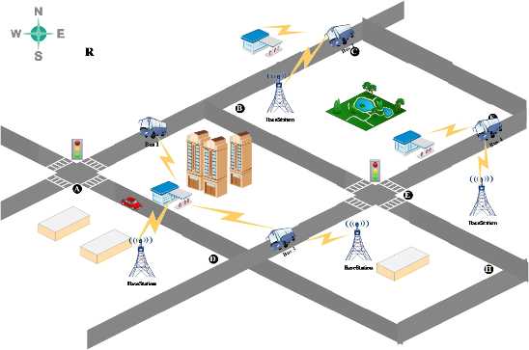

Fig.2. An example shows that we divide the city area into small fragments, such as R = {AB, AD, BC, BE, DE, EF, EH, DH, CF}, where R is the city area.

**B. Problem Statement**

In a region of interest, each vehicle equipped with amount of sensors which continuously sense the surrounding environment as it passes. However, at a specific moment, if all vehicles on a same road segment are involved in crowd-sensing, it will lead to overlapped coverage. Thus it is highly demanded to select an appropriate set to finish the crowd-sensing tasks and ensure the quality of crowd-sensing. Based on the system model, we are ready to formally define the problem of optimal selection of vehicle (SV) for maximizing the spatial-temporal coverage with SR budget constraint.

**Definition 3: SV Problem (SVP)** is to determine a set of vehicle under the budget constraint $C_{max}$ with the objective of maximizing the spatial-temporal coverage.

$\max{STC\left(Ω\right)},$

$s.t. C\left(Ω\right)≤C_{max}$. (9)

Actually, the sensing data at different road segments and at a different period time may have varying importance degree, such as we are more interested in hotspot with high traffic flow in the morning rush hour. For this reason, we introduce priority power to indicate the relative importance of each road segment where the higher priority a vehicle is more likely to be selected to join in crowd-sensing. Through analyzing historical data, it is easy to acquire traffic performance index (TPI) of each road segment. Let $D_{t_{j}}^{l_{i}}$ denote the TPI of $l_{i}(t_{j})$ at a specific time $t_{j}$, which is assumed known and normalized between 0 and 1, e.g. $D_{t_{j}}^{l_{i}}ϵ(0,1]$. With the TPI we define priority power as follow:

**Definition 4: Priority Power (PP)** is the importance of a road segment in a crowd-sensing period time, which is a function of $D_{t_{j}}^{l_{i}}$ defined as $W_{t_{j}}^{l_{i}}\left(D_{t_{j}}^{l_{i}}\right)$. So $D_{t_{j}}^{l_{i}}∝W_{t_{j}}^{l_{i}}$, thus the first order derivative of $W_{t_{j}}^{l_{i}}(D_{t_{j}}^{l_{i}})$ satisfies:

$\frac{dW_{t_{j}}^{l_{i}}}{dD_{t_{j}}^{l_{i}}}>0$ (10)

Therefore, priority power is expressed as follows:

$W_{t_{j}}^{l_{i}}=log_{2}(1+D_{t_{j}}^{l_{i}})$ (11)

With the priority power, the STC can be redefined as,

$σ\left(Ω\right)=\sum_{t_{j}∈T}{⋃_{v_{i}∈Ω }{(l}_{i}(t_{j})∙W_{t_{j}}^{l_{i}})}$ (12)

, so the SVP can be rewritten as,

$\max{σ\left(Ω\right)},$

$s.t. C\left(Ω\right)≤C_{max}$. (13)

We hope that the solution of SVP can be found with a time efficient, unfortunately, it is NP-hard even though the track of vehicles is predictable. In the next section, we will prove SVP is NP-hard and propose an improved approximation algorithm based on greedy to solve it.

**SOLUTION TO THE SVP**

**A. Complexity Analysis of SVP**

**Theorem 1.** The SVP is NP-hard even though the trajectory of all vehicles are predictable.

Proof: To prove the NP-hard property of SVP, we should demonstrate it belongs to NP firstly, and then find another NP-hard problem proven that could be reduced to it. Assuming there is a possible solution $Ω^{'}$, it is clearly that the correctness of this solution can be certified in polynomial, the time complexity of the checking algorithm is $O\left(n\right)$, which means SVP is NP. Next, we use an instance of budget maximum coverage problem as the known NP-hard, which is defined as follow. Given a collection of sets $S=\left\{S_{1},S_{2},…,S_{n}\right\}$, each set $S_{i}⊆R=\left\{r_{1},r_{2},…,r_{m}\right\}, i=1,2,3,…,n$ has a cost $c_{i}$ and an element $r_{j}, j=1,2,3,…,m$ in $R$ associated with a weight $w_{i}$.The question is whether we can find a subset $S^{'}⊆S$ that the total cost is under a given budge L and the total weight of elements in $S^{'}$ is maximized. Obviously, each set $S_{i}$ can be mapped to $σ\left(Z\right)$, $Z⊆V$, $c_{i}$ be equivalent to $C\left(Z\right)$, and weight $w_{i}$ of each element in R is mapped to the priority power, $W_{t_{j}}^{l_{i}}$ of each vehicle in V. We have mapped the formulation of SVP to budget maximum coverage problem. And then we can see that a solution of budget maximum coverage problem is also the solution of SVP. So SVP is NP-hard.

Consequently, to achieve a truthful and computationally efficient crowd-sensing system, it is highly demanded to propose an approximate algorithm for solving SVP.

**B. Approximate Algorithm to Solve SVP**

We have analyzed the NP-hardness of SVP, it becomes computationally impracticable to select an optimal set of vehicles from all the candidate vehicles when the number of candidate vehicles is huge. As for a huge metropolis like Beijing, the number of vehicles under operations is about 30,000 per day by the end of 2016 [16]. To achieve the desired computational efficiency, we propose an approximate algorithm called efficient combination query algorithm (ECQA) to solve SVP. While designing the algorithm, not only should we consider to select a vehicle with maximized STC, but also ask for less reward from CMP with budget constraint. Therefore we define the reward efficient.

**Definition 5: Reward Efficient (RE)** indicates the marginal STC achieve per unit reward.

The ECQA adopts a greedy strategy to solve the problem. The greedy policy is to select the next most reward effectiveness vehicle, which means to select a vehicle maximized marginal STC per unit reward, until the total SR exceed the budget of CMP. Mathematically, the reward-efficient for selecting a vehicle $v_{i}$ can be computed as follows:

$E_{i}=\frac{σ\left(Ω^{'}\right)-σ\left(Ω\right)}{c_{i}}$ (14)

The algorithm tries many rounds, a best vehicle with maximum RE is determined as a result of each round. In equation (14), where $E_{i}$ denotes the reward efficient of vehicle $v_{i}$, $Ω$ is solution obtained from $V$, $σ\left(Ω^{'}\right)=\{Ω⋃v_{i}\}$, and $v_{i}∈V-Ω$. The algorithm will not terminate until the budget constraint is active. The pseudo-code is listed in table 1.

**Table 1. The pseudo-code of ECQA**

|  |
| --- |
| Approximate Algorithm for SVP |
| Input: set $V=\{v_{1}, v_{2}, v_{3}, …, v_{n}\}$ of vehicle under operation, set $C=\{c_{1}, c_{2},c_{3},…,c_{n}\}$ sensing reward of each vehicle, $C_{max}$ the budget constraint of CMP, an initial set $S^{0}$ of cardinality is an integer as 3, assume the schedule time of each vehicle is known.  Output: set $Ω$ is the best set of vehicle selected by ECQA |
| Procedure:   1. Initialization 2. ; 3. for each 4. ; 5. for each 6. ; 7. ; 8. if and 9. ; 10. ; 11. end if 12. if 13. ; 14. end if 15. end for 16. end for |

The ECQA has a performance guarantee $ρ≤1$, which indicates we can obtain a solution is $ρ$ times of optimal solution in NP-hard problem [17]. The closer of value of $ρ$ to 1, the more approximation to optimal solution. In this paper, the ECQA can achieve a lower bound ratio of $1-e^{-1}$ when the cardinality as $q$ of set $S^{0}$ is not less than three, i.e. $q≥3$. Next, we will prove the following theorem about the performance guarantee of ECQA.

**Theorem 2.** The ECQA can achieve a worst performance guarantee of $1-e^{-1}$ for $|q|≥3$*.*

$σ\left(Ω\right)≥\left(1-e^{-1}\right)∙σ\left(Opt\right),q≥3$ (15)

, where $Opt$ is the set in an optimal solution.

**Proof:** Let’s redefine $v_{i}∈V,i=1,2,3,…,r$ as a vehicle added into $Ω$ in i-th iteration, Let $Ω_{k}$ denote $⋃_{i=1}^{k}v_{i}$, and $Ω=Ω_{r}$. To prove inequality (15), the following two inequalities we can derive from [18], After $i, i=1,2,3…,r+1$ iterations, we can get:

$σ\left(Ω_{i}\right)≥\left[1-\prod_{m=1}^{i}{(1-\frac{c_{m}}{C_{max}}})\right]∙σ\left(Opt\right)$, (16)

$σ\left(Ω_{r+1}\right)≥\left[1-\prod_{m=1}^{r+1}{(1-\frac{c_{m}}{C_{max}}})\right]∙σ\left(Opt\right) ≥\left[1-(1-\frac{1}{r+1})^{r+1}\right]∙σ\left(Opt\right)$

$≥\left(1-e^{-1}\right)∙ σ\left(Opt\right)$ (17)

, where $c_{m}$ denotes the sensing reward to $v_{m}$. The detailed proof of inequalities (16), (17)can be found in [17],[18]. We can easily to know that (17) is equivalent to following inequality,

$σ\left(Ω_{r+1}\right)=σ\left(Ω_{r}\right)+σ\left(\{v_{r+1}\}\right)≥\left(1-e^{-1}\right)∙ σ\left(Opt\right)$ (18)

, where $v_{r+1}$ is selected at $r+1$ round but not added to $Ω$ due to overflow budget constraint $C_{max}$. Applying (16) to (18), we get

$σ(Ω_{r}-S^{0})+σ\left(\{v_{r+1}\}\right)≥(1-e^{-1})∙σ(Opt-S^{0})$ (19)

, where the set $Opt-S^{0}$ means that an element belongs to set $Opt$ but not in set $S^{0}$.

Assuming $σ\left(\{v_{r+1}\}\right)$ is greater than $σ\left(\left\{v_{i}\right\}\right), i=1,2,…,r$, if this were the case, $v_{r+1}$ is bound to be selected before $v_{i}$ and included in $Ω_{r}$, so this assumption is invalid. Therefore, we can get,

$q∙σ(\{v_{r+1}\})≤σ(S^{0})$. (20)

From (19), (20) the following inequality can be hold

$σ\left(Ω_{r}\right)≥\left(1-e^{-1}\right)∙σ(Opt-S^{0})+(1-q^{-1})∙σ\left(S^{0}\right)$ (21)

, where $e$ is a natural base whose value is less than three, hence

$σ\left(Ω_{r}\right)≥\left(1-e^{-1}\right)∙(σ(Opt-S^{0})+σ\left(S^{0}\right))$ (21)

, if and only if $q≥3$, the inequality (21) makes sense. Clearly, $σ(Opt-S^{0})+σ\left(S^{0}\right)=σ\left(Opt\right)$, and then

$σ\left(Ω_{r}\right)≥\left(1-e^{-1}\right)∙ σ\left(Opt\right), for q≥3$ (22)

Owing to the final output of ECQA as good as $Ω_{r}$ if not better, this prove the performance guarantee of $1-e^{-1}$.

**EVALUATION**

Extensive simulations has been conducted to evaluation the performance of our proposed algorithm. The traffic trace dataset we used, the simulation setup, the compared algorithms, and the performance comparison and discussion are presented as follows.

**A. Real Traffic Trace Used and Simulation Setup**

In our simulation, to make the evaluation results convincing, the T-Drive trajectory dataset [19], [20] that contains a one-week trajectory of 10,357 buses. The total number of points in this dataset is about 15 million and the total distance of the trajectories reaches 9 million kilometers. We have imported the processed data into the Google Global Mapper, as Fig.3 shows, the distribution of the trajectories of vehicles basically covers the whole traffic network of Beijing. Our simulation is performed on traces extracted from the dataset on February 3, 2008, 6 AM to 10 PM. We randomly extract a small number of vehicles from processed dataset to participate in crowd-sensing, i.e., 10, so that the optimal solution can be found through an enumeration algorithm. Each vehicle is associated with a SR, and the SR of a vehicle is uniformly distributed in [0.7, 1.2].

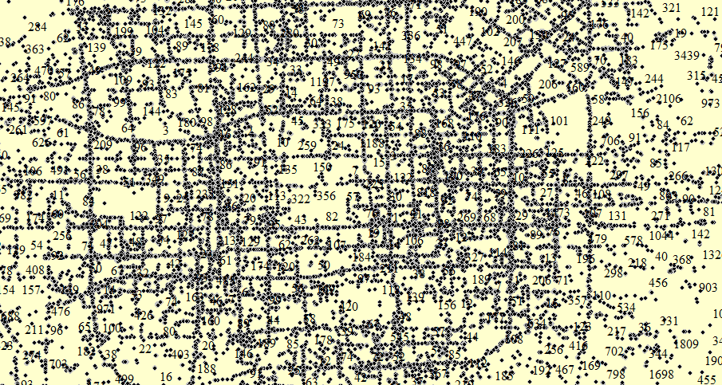

Fig.3. The distribution of the trajectories of vehicles in the dataset. In this figure, the number is the ID of each vehicles, the points is the current location of a vehicle at a specific time.

**B. Algorithm in Comparison**

The quality of crowd-sensing is related to STC, we evaluate how the total sensing reward $C_{max}$, the number of time period $m$, and the initial size of solution q’s impact on the performance.In this paper, we compare the performance of our algorithm with two baseline algorithms. **1)** The enumerative algorithm (EA) can always get the optimal vehicles from the candidate vehicles by exhaustive search, however, the SVP is NP-hard, when the number of candidate vehicles is larger, it becomes infeasible to obtain the optimal solution in polynomial time. Thus, the EA is applied simply when the number of vehicles is small. **2)** The simulated annealing algorithm (SAA) is often used to solve optimization problems, we improve a SAA to compute the SVP for maximizing the STC. Furthermore, the results are also compared with the lower bound performance guarantee STC $EA∙(1-1/e)$.

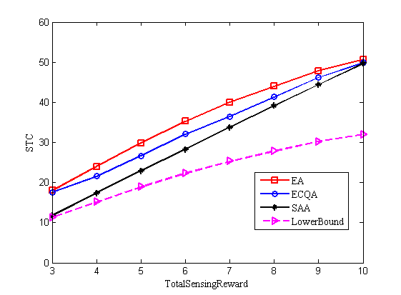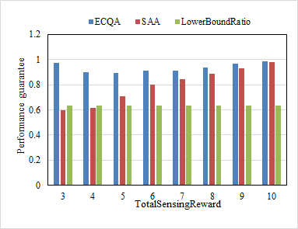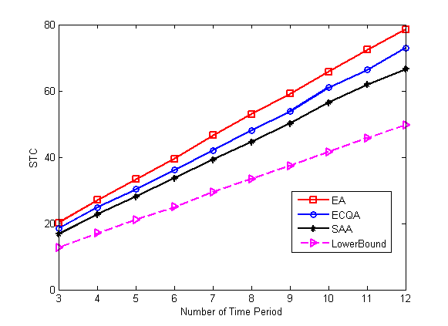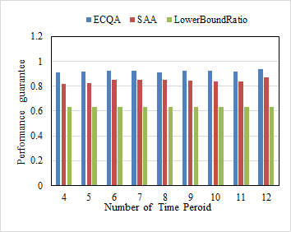

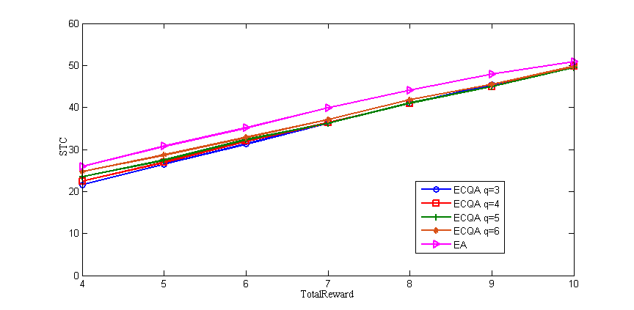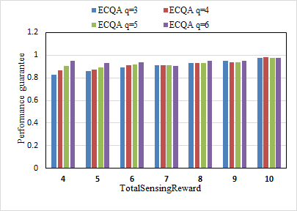

Figs.4 The total sensing reward $C_{max}$, the number of time period $m$, and the initial size of solution q impact on the performance.(a), (c) the total sensing reward $C_{max}$ is [3,10], the initial size of solution is 3, the number of period time is 6. (b), (d) the number of period is [4, 12], the total sensing reward $C_{max}$ is 6, the initial size of solution is 3. (e) the initial size of solution is [3, 6], the total sensing reward is [4, 10], the number of period time is 6.

Fig.4 illustrates the performance during the variation of the total sensing reward, the number of period time and the initial size of solution. In this group of simulations, we extract 10 vehicles from dataset. From Fig.4 (a) to (d), we can observe that the proposed algorithm outperforms the one with SAA, and gets closer to the optimal EA. In Fig.4 (a), the STC of our algorithm is larger than the SAA, and if the total sensing reward is enough, the ECQA and EA tends to equal to optimal. This result fits in with the reality. In Fig.4 (b), the performance guarantee of ECQA fluctuates around 0.9 and still provide a performance guarantee larger than $(1-1/e)$ as we have proved. This result indicates that in real cases, our algorithm is more likely to achieve full-coverage and ensure the integrity of sensing data. Fig.4 (c) shows, along with the increase of the number of period time $m$, the STC of both ECQA and competitors become larger and larger. This is due to the vehicle’s scheduled cyclically movement. The larger number of period time is set, the more covered times in one segment may as Fig.2 depicted. Additionally, the performance gap between ECQA and EA stayed nearly constant as $m$ and the performance guarantee is greater than 0.9 consistently as Fig.4 (d) shown. In Fig.4 (e) and (f), we study the important parameter $q$ influence on performance of ECQA, the $q$ is varied from 4 to 10. It is easy to see that, when total sensing reward is less than 7, the STC increase with $q$, otherwise is even nearly. This result can be understood since the total sensing reward is insufficient, the $q$ is larger, ECQA primarily searches a larger domain for optimal solution, but it takes longer execution time actually. In contract, $q$ has slightly impact on STC, which suggests that we can get a good performance even with a small $q$ and spend less running time simultaneously.

**CONCLUTION**

In this paper, we introduce mobile crowd-sensing into vehicular network to produce a vehicle-based crowd sensing network. Due to the quality of crowd-sensing is extraordinarily sensitive to the location of participants, so we take full advantage of predictable mobility pattern of public transport buses whose traveling route is scheduled. In this scenario, we need to address a crucial problem of the selection of vehicle to participate in urban sensing for maximizing spatiotemporal coverage. We have proved that the problem of selecting vehicles under a given constraint sensing reward for maximizing spatiotemporal coverage is NP-hard. Then we propose the ECQA which aims to select an optimal vehicles collection for maximizing the spatial-temporal coverage by taking the current and future positions into account of each vehicle. Moreover, through the theoretical analysis and a series of simulation on real T-Drive trajectory dataset, it is demonstrated that the ECQA can achieve a performance guarantee is still greater than $1-1/e$ of optimum and obtain better performance than alternative algorithm.

[1] Xiao M, Wu J, Huang L, et al. Online Task Assignment for Crowdsensing in Predictable Mobile Social Networks[J]. IEEE Transactions on Mobile Computing, 2017, PP(99):1-1.

[2] Dejun Yang, Guoliang Xue, Xi Fang, and Jian Tang, “Crowdsourcing to smart phones: incentive mechanism design for mobile phone sensing”, in ACM MOBICOM, 2012

[3] Mohammad Nozari Zarmehri and Ana Aguiar, “Supporting sensing application in vehicular networks”, in ACM CHANTS, 2012

[4]E.Koukoumidis,L.S.Peh,andM.R.Martonosi,“Signalguru:Leveraging mobile phones for collaborative trafﬁc signal schedule advisory,” in Proc. 9th Int. Conf. Mobile Syst., Appl. Serv., ACM, 2011, pp. 127–140.

[5] A. Thiagarajan et al., “Vtrack: Accurate, energy-aware road trafﬁc delay estimationusingmobilephones,”inProc.7thACMConf.EmbeddedNetw. Sensor Syst., ACM, 2009, pp. 85–98.

[6] P. Dutta, P. M. Aoki, and et al., “Common Sense: participatory urban sensing using a network of handheld air quality monitors,” in SenSys 2009, pp. 349–350.

[7] A.Farshad, M. K. Marina, and F. Garcia, “Urban WiFi characterization via mobile crowdsensing,” in Proc. Netw. Oper. Manage. Symp., IEEE, 2014, pp. 1–9.

[8]TRAC: Truthful auction for location-aware collaborative sensing in mobile crowdsouring

[9] D. Yang, G. Xue, and et al., “Crowdsourcing to smartphones: Incentive mechanism design for mobile phone sensing,” in MobiCom 2012, pp. 173–184.

[10] S. Reddy, D. Estrin, M. Hansen, and M. Srivastava, “Examining micropayments for participatory sensing data collections,” in UbiComp 2010, pp. 33–36

[11] High Quality Participant Recruitment in Vehicle-based Crowdsourcing using Predictable Mobility

[12] L. Kazemi and C. Shahabi, “Geocrowd: Enabling query answering with spatial crowdsourcing,” in ACM SIGSPATIAL 2012, pp. 189–198.

[13] J. Huang and H.-S. Tan, “Vehicle future trajectory prediction with a DGPS/INS-based positioning system,” in American Control Conference, 2006.

[14] Kang L, Poslad S, Wang W, et al. A Public Transport Bus as a Flexible Mobile Smart Environment Sensing Platform for IoT[C]// International Conference on Intelligent Environments. IEEE, 2016.

[15] Rai A, Chintalapudi K K, Padmanabhan V N, et al. Zee:zero-effort crowdsourcing for indoor localization[C]// 2012:293-304.

[16]<https://baike.baidu.com/item/%E5%8C%97%E4%BA%AC%E5%85%AC%E4%BA%A4/10750049?fr=aladdin>

[17 ] MAXIM S. A note on maximizing a sub-modular set function subject to knapsack constraint [ J] . Operations Research Letters, 2004,32( 5): 41-43

[18]Khuller S, Moss A, Naor J. The budgeted maximum coverage problem [M]. Elsevier North-Holland

[19] Jing Yuan, Yu Zheng, Xing Xie, and Guangzhong Sun. Driving with knowledge from the physical world. In The 17th ACM SIGKDD international conference on Knowledge Discovery and Data mining, KDD’11, New York, NY, USA, 2011. ACM.  
[20] Jing Yuan, Yu Zheng, Chengyang Zhang, Wenlei Xie, Xing Xie, Guangzhong Sun, and Yan Huang. T-drive: driving directions based on taxi trajectories. In Proceedings of the 18th SIGSPATIAL International Conference on Advances in Geographic Information Systems, GIS ’10, pages 99-108, New York, NY, USA,2010. ACM.